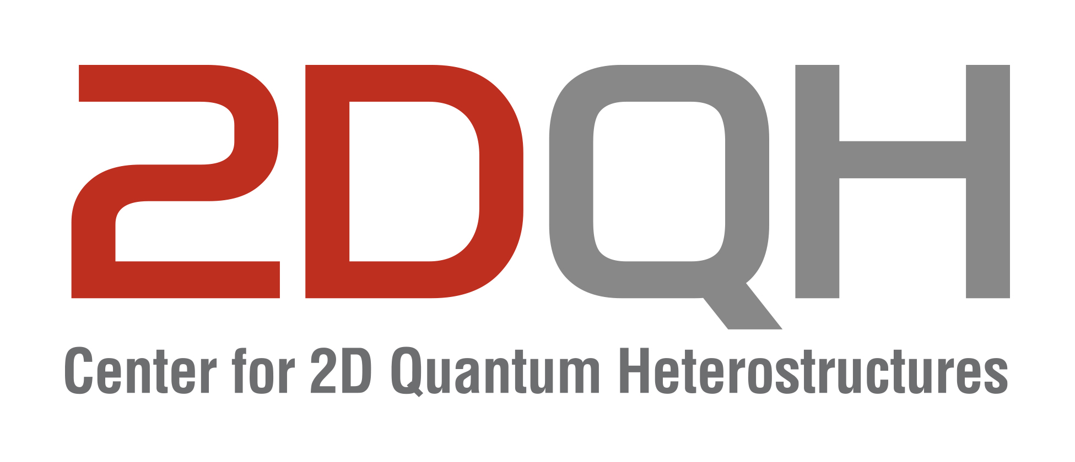

IBS 2DQH Seminar
November 26 2024, 10:30 AM
Sungkyunkwan University, Suwon

Quantum Electronic Transport at the Clean Interfaces of Topological van der Waals Heterostructures
Joon Young Park
Department of Physics Harvard University
Abstract
This talk explores recent advances in van der Waals (vdW) heterostructures for creating highly tunable topological quantum heterostructures with pristine, clean interfaces. First, I will introduce "double-sided vdW epitaxy," a novel concept that utilizes both surfaces of an atomically thin crystal membrane as growth substrates, enabling electrons to resonantly tunnel between aligned topological insulator (TI) surfaces while conserving energy, momentum, and spin helicity.
In the second part, I will discuss the flux-parity controlled superconducting diode effect observed in high-quality Corbino-geometry Josephson junctions, fabricated on a single surface of a bulk-insulating TI protected by a Te thin film, a one-dimensional vdW semiconductor. The even- and odd-magnetic flux quanta states exhibit alternating diode polarity, attributed to a topological phase of Andreev bound states.
Finally, I will provide an outlook on quantum electronic transport in the ultra-clean limit, enabled by novel fabrication techniques under controlled environments.

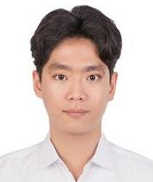
Brief Biography
Dr. Joon Young Park is a Research Associate in the Department of Physics at Harvard University since 2024 and formerly a Post-Doctoral Fellow from 2019 to 2024, where he leads advanced research on topological quantum devices based on van der Waals (vdW) heterostructures under the guidance of Prof. Philip Kim. He received his B.S. in Physics and Astronomy from Seoul National University in 2012 and earned his Ph.D. in Physics from the same institution in 2019. His doctoral work, supervised by Prof. GyuChul Yi, focused on the electronic transport properties of topological insulatorbased vdW heterostructures grown by molecular beam epitaxy. Dr. Park's research focuses on quantum electronic transport in vdW materials, with particular interest in topological materials, mesoscopic superconductivity, and applications in topological quantum computing. His work includes the fabrication and characterization of vdW quantum electronic devices, the development of unconventional techniques for enabling clean-limit transport, and exploration of novel topological states.

