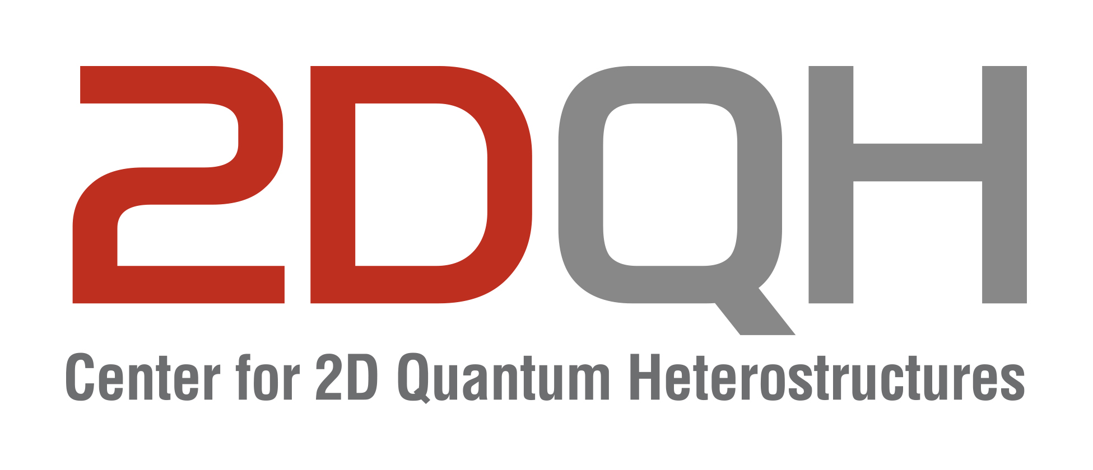

IBS 2DQH Seminar
July 29 2024, 11:00 AM
Sungkyunkwan University, Suwon

Mixed-dimensional semiconductor nano/heterostructures for energy and quantum applications
Jinkyoung Yoo
Center for Integrated Nanotechnologies, Los Alamos National Laboratory
Abstract
Advances in nanoscience have overcome materials compatibility issues and delivered novel functionalities. The progress has come with various nanomaterials, such as two-dimensional (2D) materials, nanowires, nanoparticles, and other hierarchical materials. There is no silver bullet as a universal solution for various applications. Therefore, heterostructuring to fabricate multi-dimensional or hybrid architectures, in which individual constituents’ properties are designed, is a common and promising way.
In this seminar, I will discuss epitaxy of conventional semiconductors, such as silicon (Si), germanium (Ge), and wide bandgap semiconductors (GaN, ZnO), at nanoscales and on non-planar architectures and 2D materials. Although epitaxy of Si-Ge has been studied several decades, the growth behaviors at nano/mesoscales are different from the previous knowledge.
In the first part, I’ll present radial epitaxy of Si/Ge and impacts of the epitaxy on energy applications including lithium-ion battery anodes and harvesting devices.
The main topic of the second part will be multi-dimensional architectures composed of conventional semiconductors and emerging 2D materials. I’ll present van der Waals and remote epitaxy techniques enabling to integrate incommensurate materials without degradation of materials quality. The examples are Ge on 2D materials, exotic phase of group-IV semiconductors, interface between 2D and conventional materials, and microcavities embedding a 2D material. The studies will be discussed in an integrated framework encompassing nucleation/growth mechanisms, functionalities, and prospects of novel applications of mixed-dimensional heterostructures.
In addition to the technical talk, I’ll present the capabilities of the Center for Integrated Nanotechnologies, a national user facility.
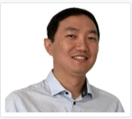
Brief Biography
Jinkyoung Yoo is the co-leader of Quantum Materials Systems thrust of The Center for Integrated Nanotechnologies (CINT), a National Nanoscience Research Center supported by U.S. Department of Energy (DOE), in Los Alamos National Laboratory. He is also a member of the Quantum Science Center, one of five DOE Quantum Information Science Center. He is serving as a panel of the technology council of heterogeneous integration for Semiconductor Research Corporation. He is a principal editor of Journal of Materials Research, edited by Materials research Society and published by Springer-Nature. He received his Ph. D. (Materials Science) from the Pohang University of Science and Technology (POSTECH) in South Korea. He worked at CINT as a post-doctoral researcher from 2010 to 2013. He then joined CINT as a technical staff member in 2013. His research encompasses synthesis of semiconductor nanowire heterostructures, 2D/3D heterostructures, electrical/optical characterizations, and device fabrication to integrate fundamental understandings of nanoscience into applicable devices.

