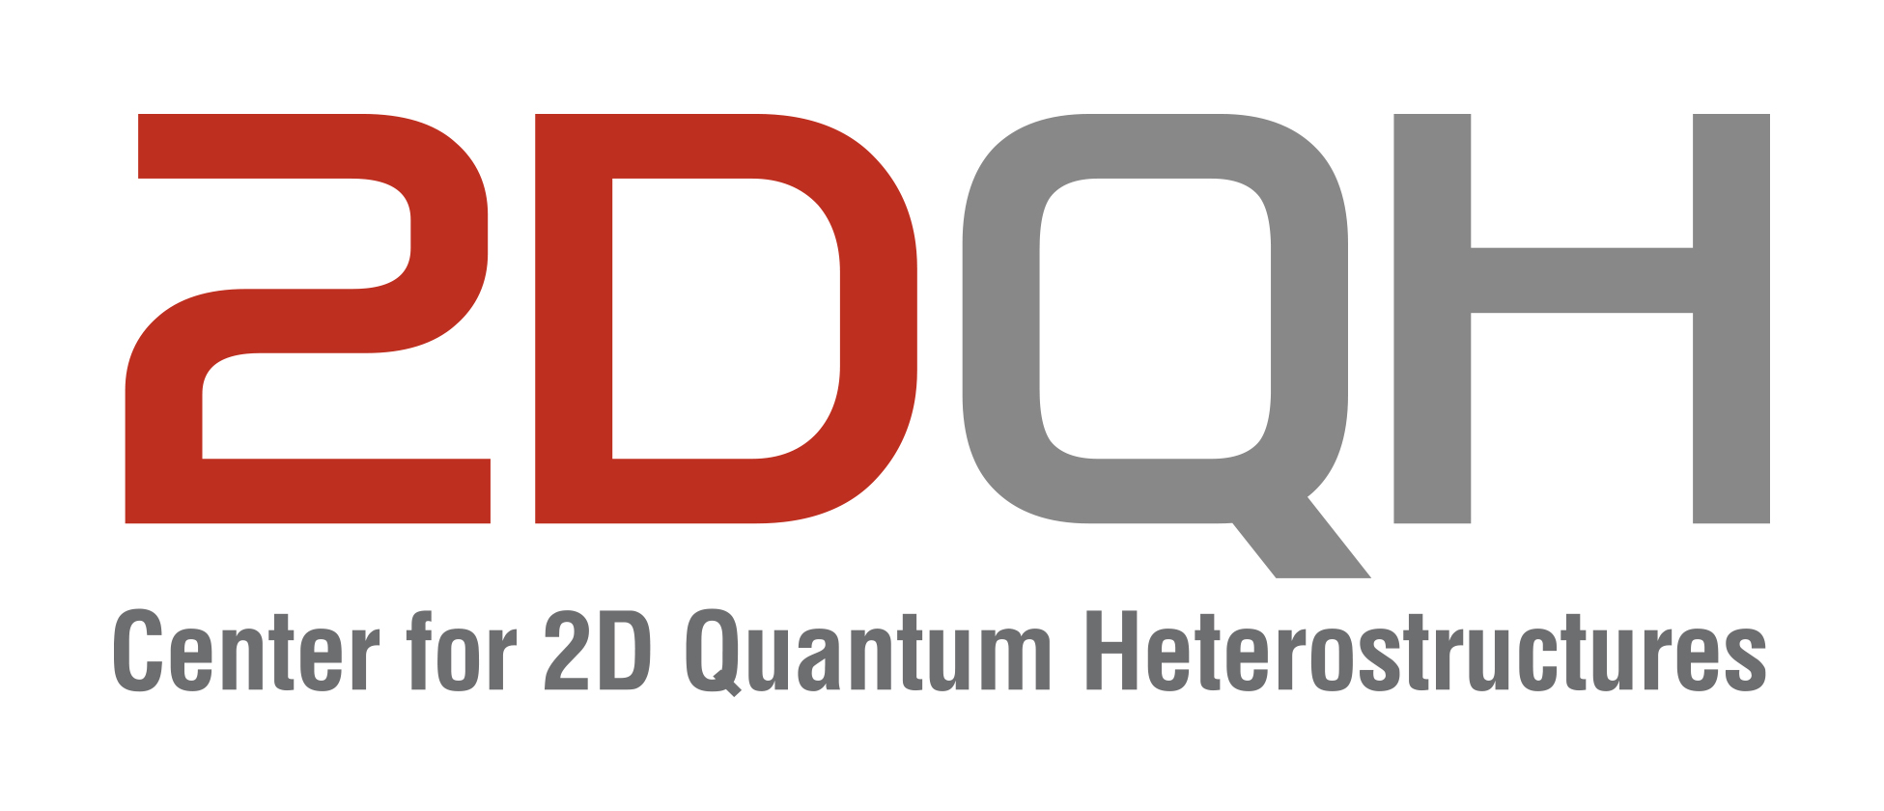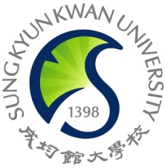

IBS 2DQH Seminar
June 14 2024, 11:00 AM
Sungkyunkwan University, Suwon

Two-Dimensional Semiconductors for Advanced Electronics
Lain-Jong (Lance) Li
The University of Hong Kong
Abstract
With the scaling of dimensions, the control of transistor gates weakens due to increased source-drain tunneling. Therefore, reducing the thickness of the transistor body is necessary to ensure effective electrostatic control. The utilization of new materials such as "ultra-thin" 2D semiconducting materials has garnered attention. In this presentation, I aim to provide an analysis and rationale regarding the potential for scaling device dimensions, potentially down to the 1nm technology node, utilizing 2D transition metal dichalcogenides (TMD) semiconductors. The in-depth analysis comparing 2D material and Si SRAM cells across different technology nodes indicates that 2D materials-based SRAM outperforms Si SRAM in terms of stability, read access time, write speed, and dynamic power efficiency. The benefits are especially pronounced in scaled-down technology nodes such as the 1 nm node. However, several key challenges are yet to be addressed including large-area scalable growth of high-quality 2D materials, reducing contact resistance to p-type 2D semiconductors, and developing low-EOT high-k dielectrics which can be integrated with 2D materials without damaging the 2D materials.
Brief Biography
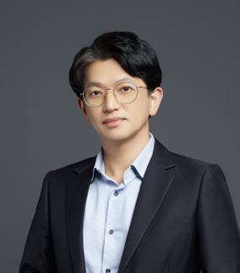
Current position:
Professor, Chair of Future Electronics & Chair of Physics by Courtesy
Director, HKU Microelectronics center
Mechanical Engineering, University of Hong Kong
Associate Editor of Nano Letters (ACS)
Education:
- BA (1994) and MSc (1996) of Chemistry, National Taiwan University
- D.Phil (2006) of Condensed Matter Physics, Oxford University.
Experiences:
- Assistant Professor, MSE, NTU (Singapore) Jun 2006 – Dec 2009
- Associate Research Fellow, Academia Sinica (Taiwan) / Feb 2010 – Apr 2014
- Research Fellow (Tenured), Academia Sinica (Taiwan) / May 2014 – Jul 2014
- Associate Professor, King Abdullah University of Science and Technology (Saudi Arabia) / Aug 2014 – Jul 2016
- Full Professor, King Abdullah University of Science and Technology (Saudi Arabia) / Aug 2016 – Dec2017
- Chief Technology Officer (CTO), Nitronix Nanotechnology,Taiwan 2015- Dec 2017
- Director, Corporate Research in Taiwan Semiconductor Manufacturing Company
(Taiwan)/Dec2017-Dec2020

