Chong Min Koo, PhD
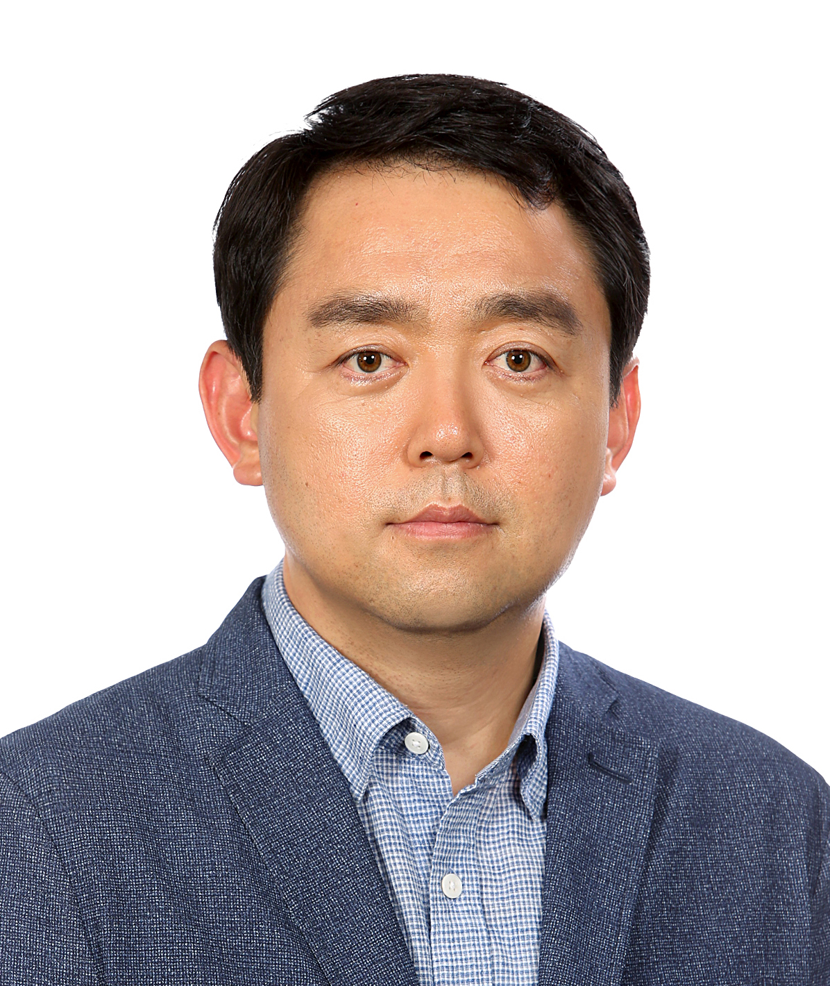
Professor
School of Advanced Materials Science and Engineering
Sungkyunkwan University
#25221, Engineering Building II
2066 Seobu-ro, Jangan-gu, Suwon, 16419, Republic of Korea
Tel: +82-31-290-7351, E-mail: chongminkoo@skku.edu, chongminkoo@gmail.com

Education
B.S., Dept. of Industrial Chemistry, Hangyang University (1997)
M.S., Dept. of Chemical Engineering, KAIST (1999)
Ph.D., Dept. of Chemical Engineering, KAIST (2003)

Research Career
Professor, Advanced Materials Science and Engineering, Sungkyunkwan University (2022-present)
Center Heard, Principal Research Scientist, Korea Institute of Science and Technology (2007–2022)
Professor, University of Science and Technology (2010–2022)
Professor, KU-KIST Graduate School, Korea University (2017–2022)
Postdoctoral fellow, University of Minnesota (2003-2005)
Senior Research Scientist, LG Chemicals (2005-2007)
Visiting Scholar, Materials Sci. & Eng. Penn. State University (2011, 2013)
Visiting Scholar, Materials Sci. & Eng. Drexel University (2017-2018)

Honors and awards
2021 Top 10 Nano Technology, Ministry of Science, ICT and Future Planning & Ministry of Trade, Industry and Energy, Republic of Korea (2021)
Seoktop (석탑) Professor Award, Korea University (2021)
S-Oil Future Scientist Award (2021)
NST Best Research Award, Minster Award, Ministry of Science, ICT and Future Planning, Republic of Korea (2021)
KOPTRI Award, Korea Polymer Society (2021)
KISTian Award, the Grand Prize (2021)
KIST Tenured Researcher (2021)
2020 Top 10 Science News in Korea, Korean Federation of Science and Technology Societies (2020)
Korean President Award, Person with Distinguished Merits in the Contribution to National Scientific and Technological Development, (2019)
Korean Scientist of the Month (September) (이달의 과학기술인상), Ministry of Science, ICT and Future Planning (2018)
Best Senior Academic Award (중견학술상), Korea Polymer Society (2018)
Best Professor Award of UST (2017)
Best Publication Award of UST (2017)
KISTian Award (KIST인상) (October, 2017)
LG Young Scientist Award in Industrial Chemistry, Korea Society of Industrial and Engineering Chemistry (2017)
Songgok Scientist Award (송곡과학기술자상), Korea Institute of Science and Technology (2017)
KIST Young Fellow (2017)
KIST Award (November, 2016)
Best Research Team Award, Korea Institute of Science and Technology (2015)
KIST Unsung Hero Award (2012)
Marquis Who’s Who In the World (2012, 2013)
Best Research Team Award, Korea Institute of Science and Technology (2011)
LG Group Best Research Award (2007)
LG Chemicals Best Research and Development Award (2007)

Selected Publications
- A. Iqbal, F. Shahzad, K. Hantanasirisakul, M. K. Kim, J. Kwon, J. Hong, H. Kim, D. Kim, Y. Gogotsi*, and C. M. Koo*, “Anomalous absorption of electromagnetic waves by 2D transition metal carbonitride Ti3CNTx (MXene)” Science 369, 446-450, 2020.
- F. Shahzad, M. Alhabeb, C. Hatter, B. Anansori, S. M. Hong, C. M. Koo*, and Y. Gogotsi*, “EMI shielding with 2D transition metal carbides MXenes”, Science 353, 2237-1140, 2016.
- D. He, N. Zhang, A. Iqbal, Y. Ma, X. Lu, Z. A. Qiao, J. H. Yu, H. Xu, W. Wang, R. Zhao, X. Li, Z. Zhou, C. Jin, C. M. Koo*, C. Wang*, “Multispectral electromagnetic shielding using ultra-thin metal-metal oxide decorated hybrid nanofiber membrane”, Communications Materials 2, 1-9, 2021.
- T. Yun, H. Kim, A. Iqbal, Y. S. Cho, G. S. Lee, M. K. Kim, S. J. Kim, D. Kim, Y. Gogotsi*, S. O. Kim* and C. M. Koo*, “Electromagnetic shielding of monolayer MXene assemblies”, Advanced Materials 32, 1906769, 2020.
- F. Shahzad, A. Iqbal, H. Kim, C. M. Koo*, “2D transition metal carbides (MXenes): applications as an electrically conducting materials”, Advanced Materials 32, 2002159, 2020.
- A. Iqbal, P. Sambyal, and C. M. Koo*, “2D MXenes for electromagnetic shielding: A review”, Advanced Functional Materials 2000883, 2020.
- S. Lee, E. H. Kim, S. Yu, H. Kim, C. Park, T. H. Park, H. Han, S. W. Lee, S. Baek, W. Jin, C. M. Koo*, and C. Park*, “Alternating-current MXene polymer light-emitting diodes”, Advanced Functional Materials 2001224, 2020.
- D. Kim, T. Y. Ko, H. Kim, G. H. Lee, S. Cho*, and C. M. Koo*, “Nonpolar dispersion of 2D Ti3C2Tx MXene flakes via simultaneous interfacial chemical grafting and phase transfer method”, ACS Nano 13, 13818-13828, 2019.
- T. H. Park, S. Yu, M. Koo, H. Kim, E. H. Kim, J. E. Park, B. Ok, B. Kim, S. H. Noh, C. Park, E. Kim, C. M. Koo*, and C. Park*, “Shape-adaptable 2D titanium carbide (MXene) heater”, ACS Nano 13, 6835-6844, 2019.
- S. Yu, H. Cho, J. Hong, H. Park, J. C. Jolly, H. S. Kang, J. H. Lee, J. Kim, S. H. Lee, A. S. Lee, S. M. Hong, C. Park, S. Yang*, and C. M. Koo*, “Shaping micro-clusters via inverse jamming and topographic close-packing of microbombs”, Nature Communications 8, 721, 2017.
- J. H. Lee, K. S. Han*, J. S. Lee, A. S. Lee, S. K. Park, S. Y. Hong, J. C. lee, K. T. Mueller*, S. M. Hong, and C. M. Koo*, “Facilitated transport in smectic ordered ionic liquid crystals”, Advanced Materials 28, 9301-9307,2016.
- B. Kim, M. H. Kim, Y. D. Park, K. Min, J. Kim, S. M. Hong, S. O. Kim*, and C. M. Koo*, “Electric actuation of nanostructured thermoplastic elastomer gels with ultra large electrostriction coefficient“, Advanced Functional Materials 21, 3242-3249, 2011.

Books
- Two dimensional Materials for EMI Shielding, Wiley (2021)
- 2D Metal Carbides and Nitrides (MXenes), Springer Nature (2019)
- Advanced Materials for Electromagnetic Shielding, John Wiley & Sons (2017)
-Thermal Transport in Carbon-based Nanomaterials, Elsevier (2018)
-Thermoplastic Elastomers, InTech (2012)

